Prompt Engineering Project 1
Zero-Shot & Few-Shot Data Extraction

Submitted By:
Name: Kavineshwaran
Internship: Prompt Engineering
Organisation: Decode Labs
Batch: 2026

Objective:
The objective of this project is to design a prompt capable of extracting structured information from unstructured text and converting it into valid JSON format.
The project aims to:
• To know Prompt Engineering concepts well
• Implement Zero-Shot and Few-Shot Prompting
• Use delimiters to separate instructions and data
• Handle missing information using null values
Problem Statement:
- Information is often available in paragraph form rather than structured databases.
- For example, superhero descriptions may contain names, aliases, cities, and powers hidden inside sentences.
- The challenge is to design a prompt that can identify these details and return them in a consistent JSON structure.
Tools Used:
- GitHub
- ChatGpt
- Gemini
- Prompt engineering
- Json

Concepts:

Zero-Shot Prompting
Zero-Shot Prompting refers to giving instructions to an AI model without providing examples.
Example:
Extract the name, email, phone number, and city from the given text and return the output in JSON format.

Few-Shot Prompting
Few-Shot Prompting involves providing example input-output pairs before giving the actual task.
This helps the model understand the expected response format.

Delimiters
Delimiters such as triple quotation marks (""") are used to clearly separate instructions from user data.

Structured Output Generation
The prompt forces the AI model to generate only valid JSON output without any additional explanations.
Prompt:
You are a data extraction engine.

Extract the following fields:
- hero_name
- alias
- city
- power

Rules:
1. Return only valid JSON.
2. Do not add explanations.
3. If a field is missing, return null.
4. Power should be returned as an array.

Example 1

Input:
"""
Hero Name: Clark Kent
Alias: Superman
City: Metropolis
Power: Flight, Super Strength, Heat Vision
"""

Output:
{
"hero_name": "Clark Kent",
"alias": "Superman",
"city": "Metropolis",
"power": ["Flight", "Super Strength", "Heat Vision"]
}

Example 2

Input:
"""
Hero Name: Bruce Wayne
Alias: Batman
City: Gotham
Power: Martial Arts, Detective Skills
"""

Output:
{
"hero_name": "Bruce Wayne",
"alias": "Batman",
"city": "Gotham",
"power": ["Martial Arts", "Detective Skills"]
}

Test Cases:

Test case 1:
Input:
The oceans are guarded by ArthurCurry.
Most citizens recognize him by the name Aquaman.
Living in Atlantis, he protects underwater kingdoms using Telepathy and the ability of Underwater Breathing.
Output:
{"hero_name":"ArthurCurry","alias":"Aquaman","city":"Atlantis","power":["Telepathy","Underwater Breathing"]}
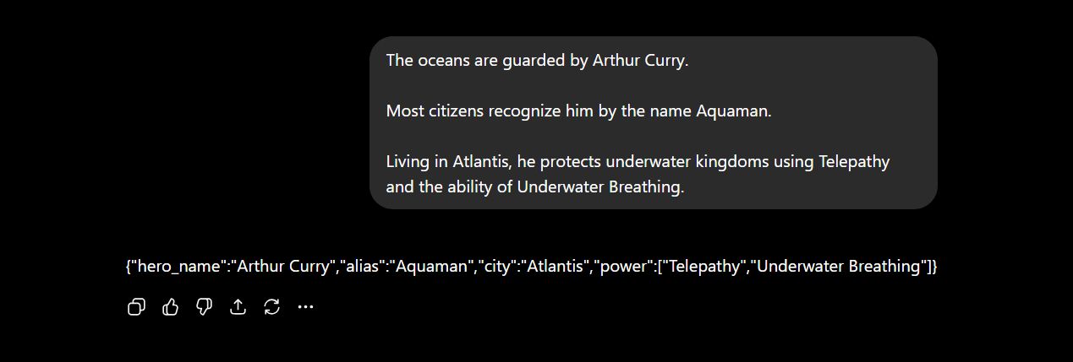
Test case 2:
Input:
Peter Parker spends most of his time protecting Queens as Spider-Man. Thanks to his Spider Sense, Web Shooting abilities, and Wall Crawling powers, he can stop criminals before they escape.
Output:
{"hero_name":"Peter Parker","alias":"Spider-Man","city":"Queens","power":["Spider Sense","Web Shooting","Wall Crawling"]}
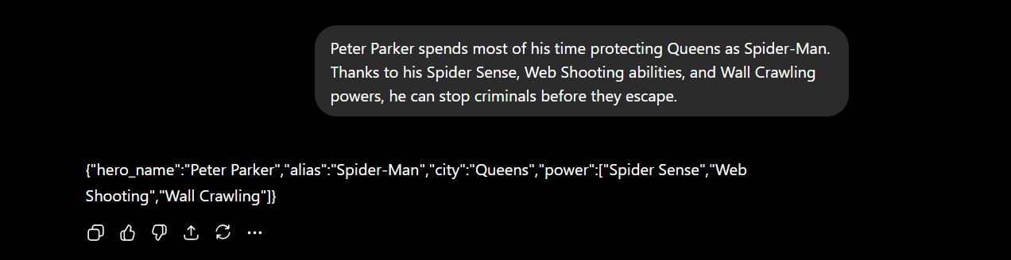
Test case 3:
Input:
Known throughout Central City, Barry Allen takes on the identity of The Flash. His incredible Super Speed and Time Travel capabilities allow him to respond to threats in an instant.
Output:
{"hero_name":"Barry Allen","alias":"The Flash","city":"Central City","power":["Super Speed","Time Travel"]}
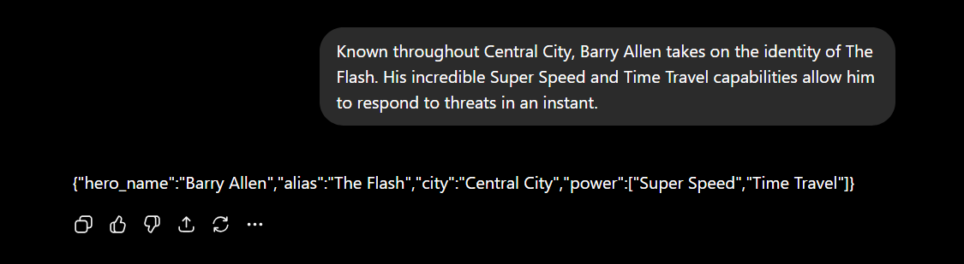
Test case 4:
Input:
Thor Odinson is one of the greatest protectors of Asgard. People know him simply as Thor. He commands Lightning Control and possesses tremendous Super Strength.
Output:
{"hero_name":"Thor Odinson","alias":"Thor","city":"Asgard","power":["Lightning Control","Super Strength"]}

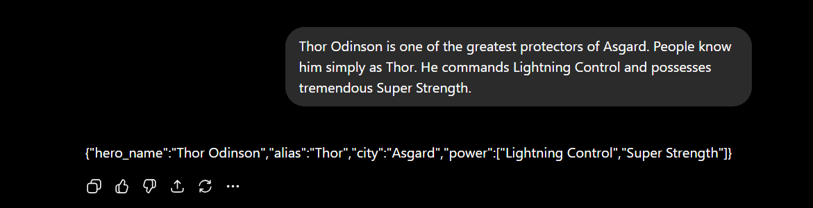Result:
The prompt successfully extracted structured information from different forms of unstructured text.
The generated JSON outputs remained consistent across all test cases.
Missing information was correctly represented using null values.
The use of Few-Shot Prompting improved response consistency and formatting accuracy.

Conclusion:
This project successfully demonstrated the use of Prompt Engineering techniques to extract structured information from unstructured text. By using Few-Shot Prompting and delimiters, accurate JSON outputs were generated consistently.

